Executive Summary

Background

This was a knowledge exchange opportunity for staff from University of the Highlands and Islands (UHI) to meet with Prof. Wolfgang Greller of the Education University in Vienna. Prof. Frank Rennie and John Alexander Smith (UHI) travelled to Vienna to meet with Prof. Greller as part of an ERASMUS+ Exchange. 14-17 December 2018 in Vienna, Austria.

Prof. Geller has previously worked at the University of the Highlands and Islands as Head of Learning Environments before talking up senior management roles at University of Klagenfurt, The Open University of the Netherlands and the Vienna University of Education where he currently holds the post of Chair in Innovative Learning and Language Education.
Prof. Greller has been actively involved in research and development in the area of Education innovation for most of his academic career.

Prof. Greller is a passionate believer in the opportunities that technology has to offer to the knowledge society, both in terms of enhancement of learning and in reaching out to new learners. In remote and rural communities it is often the only way for people to access higher education. However, he is also of the opinion that technology alone does not produce new knowledge or learning and that new developments need to have a pedagogic and learner-centred approach.

Experience in commerce and education has shown that online solutions are at their best when built upon a traditional well-established structure. The pedagogic concept of Blended Learning is increasingly supported by universities and governments who realise that it provides a more sustainable approach than purely online offerings. This goes some way towards recognising that we cannot ignore pedagogic concepts that have been successful for decades before the internet arrived and still are.

Prof. Greller has particular interest in Technology Enhanced Learning. His current research interests focus especially on Learning and Knowledge Analytics, Language Technologies for learning support, Learning Networks, and Mobile Learning,

UHI have recently - (2018) procured a new Learning Environment and are embarking on a comprehensive staff development programme to support embedding learning, teaching and enhancement themes into the digital content.

This knowledge exchange was arranged to discuss the implementation and exploitation of Learning Analytics offered by the new Learning Platform (Brightspace by D2L) and to discuss opportunities for using Learning Analytics to support students staff and the University as well as and discussing a critical pathway to implementation and adoption of Learning Analytics at UHI.

Meeting Vienna, Austria – 14, 17 December 2018
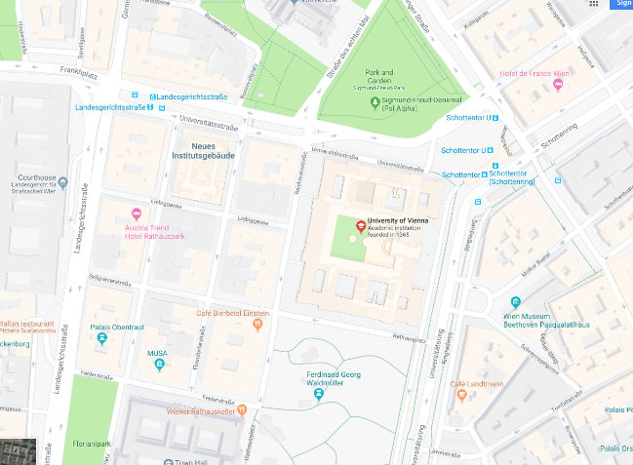
Figure 1Figure 1University of Vienna
Prof Wolfgang Greller, Education University of Vienna with Prof. Frank Rennie, Lews Castle College and John A Smith, Learning and Information Services , Executive Office at University of the Highlands and Islands.
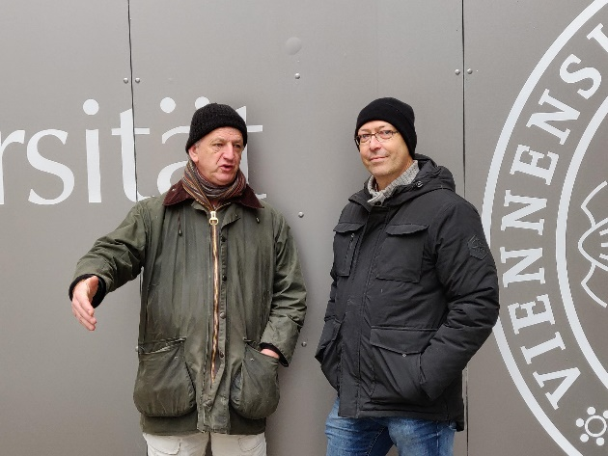
Figure Prof Frank Rennie (left), Prof. Wolfgang Greller (right)

Figure 3 Prof Frank Rennie (left), Prof. Wolfgang Greller (right

Ethical Policy and Data Privacy
The following section highlights academic papers and framework documentation that are suitable as catalyst primers for discussion.
- Privacy and analytics: it's a DELICATE issue a checklist for trusted learning analytics
The widespread adoption of Learning Analytics (LA) and Educational Data Mining (EDM) has somewhat stagnated recently, and in some prominent cases even been reversed following concerns by governments, stakeholders and civil rights groups about privacy and ethics applied to the handling of personal data. In this ongoing discussion, fears and realities are often indistinguishably mixed up, leading to an atmosphere of uncertainty among potential beneficiaries of Learning Analytics, as well as hesitations among institutional managers who aim to innovate their institution's learning support by implementing data and analytics with a view on improving student success. In this paper, we try to get to the heart of the matter, by analysing the most common views and the propositions made by the LA community to solve them. We conclude the paper with an eight-point checklist named DELICATE that can be applied by researchers, policy makers and institutional managers to facilitate a trusted implementation of Learning Analytics.
Hendrik Drachsler Open university of the Netherlands , Wolfgang Greller University of Education, Veinna . LAK '16 Proceedings of the Sixth International Conference on Learning Analytics & Knowledge
Figure 4 Informal Meeting Prof. Wolfgang Greller (Left), Prof. Frank Rennie (Right)

- Learning Analytics: Ethical & Issues and Dilemmas
The field of learning analytics has the potential to enable higher education institutions to increase their understanding of their students’ learning needs and to use that understanding to positively influence student learning and progression. Analysis of data relating to students and their engagement with their learning is the foundation of this process. There is an inherent assumption linked to learning analytics that knowledge of a learner’s behavior is advantageous for the individual, instructor and educational provider. It seems intuitively obvious that a greater understanding of a student cohort and of the learning designs and interventions to which they best respond would be of benefit to students and, in turn, for the retention and success rate of the institution. Yet, such collection of data and its use faces a number of ethical challenges, including issues of the location and interpretation of data; informed consent, privacy and the de-identification of data; and the classification and management of data.
Approaches taken to understand the opportunities and ethical challenges of learning analytics necessarily depend on a range of ideological assumptions and epistemologies. This paper proposes a socio-critical perspective on the use of learning analytics. Such an approach highlights the role of power, the impact of surveillance, the need for transparency and an acknowledgment that student identity is a transient, temporal and context-bound construct. Each of these affects the scope and definition of the ethical use of learning analytics. We propose six principles as a framework for a number of considerations to guide higher education institutions to address ethical issues in learning analytics and challenges in context-dependent and appropriate ways.
http://oro.open.ac.uk/36594/ Slade, Sharon and Prinsloo, Paul (2013). Learning analytics: ethical issues and dilemmas. American Behavioral Scientist, 57(10) pp. 1509–1528.
- An evaluation of policy frameworks for addressing ethical considerations in learning analytics
Higher education institutions have collected and analysed student data for years, with their focus largely on reporting and management needs. A range of institutional policies exist which broadly set out the purposes for which data will be used and how data will be protected. The growing advent of learning analytics has seen the uses to which student data is put expanding rapidly. Generally though the policies setting out institutional use of student data have not kept pace with this change.
Institutional policy frameworks should provide not only an enabling environment for the optimal and ethical harvesting and use of data, but also clarify: who benefits and under what conditions, establish conditions for consent and the de-identification of data, and address issues of vulnerability and harm. A directed content analysis of the policy frameworks of two large distance education institutions shows that current policy frameworks do not facilitate the provision of an enabling environment for learning analytics to fulfil its promise.
http://oro.opn.ac.uk/36934/ Prinsloo, Paul and Slade, Sharon (2013). An evaluation of policy frameworks for addressing ethical considerations in learning analytics. In: Third Conference on Learning Analytics and Knowledge (LAK 2013), 8-12 Apr 2013, Leuven, Belgium, ACM, pp. 240–244.

- Learning Analytics Avoiding Failure
The promise of learning analytics is that they will use educational data to improve the quality and value of the learning experience within our schools and universities. These promised gains come at a cost. Investment in data collection and storage, development of context-sensitive algorithms, and staff development are all important, but they do not guarantee success. To increase the potential for success, we went to the learning analytics experts and asked how best to avoid failure.
Ferguson, Rebecca and Clow, Doug (2017). Learning Analytics: Avoiding Failure. Educause Review Online, 31.07.2017

- Effective Learning Analytics
LA Cymru curriculum analytics workshop, 28th November 2018.
Most learning analytics projects focus on improving student success, but the rich data sources increasingly available to us can also be used to gain insight into the effectiveness of the curriculum.
This is a relatively unexploited area which has the potential to significantly enhance our understanding of how to create engaging and effective curricula – to find out what is and isn’t working for students.
Curriculum analytics, as we’re calling it, is one area being investigated within the LA Cymru project . To take this forward JISC organised a workshop in Cardiff and Vale College at the end of November with participants from Welsh universities and other institutions in the UK.
Niall Sclater December 17, 2018

- Enabling Systematic Adoption of Learning Analytics through a Policy Framework
Learning analytics (LA) has shown a great potential in improving learning experience and enhancing pedagogical effectiveness. However, the adoption of LA in higher education involves various social, cultural, and technical issues that need to be addressed strategically. We present a study that aims to assist with the development of institutional LA policies to ensure effective and legitimate adoption of LA. The study takes an action research approach and involves key stakeholders directly, so as to incorporate a wide range of perspectives in the policy formation. Ethics and privacy issues were considered the priority element in a LA policy and the top concern for students. A sense of uncertainty about the returns in investment was observed among senior managers, whereas teaching staff were mostly worried about time pressure and the potential of LA to be used for performance appraisal. This poster presents a policy framework that can be used to support institutional readiness assessment, strategy formation, and policy development.
Yi-ShanTsai, Maren Scheffel, Dragan Gašević - 2018

- Defining Analytics
- Institutional Analytics
- Learning Analytics

- Guest Editorial: Special Section on Learning Analytics
According to the Society for Learning Analytics Research (SoLAR), learning analytics is defined as “the measurement, collection, analysis, and reporting of data about learners and their contexts, for purposes of understanding and optimising learning and the environments in which it occurs.” The field of learning analytics was established by drawing from a wide range of areas such as learning sciences, (educational) data mining, language technologies, machine learning, information visualization, psychology, and educational theory.

Dragan Gasevic, George Siemens, and Carolyn Penstein Rose - 2017
The Scope of Analytics
  - Analytics for the Student
  - Analytics for the Tutor
  - Analytics for the Manager
  - Analytics for the institution

Figure 5 Sphere of influence of Learning Analytics

Implementing Learning Analytics at University of the Highlands and Islands

SEILA


To assist European universities to become more mature users and custodians of digital data about their students as they learn online, the SHEILA project will build a policy development framework that promotes formative assessment and personalized learning, by taking advantage of direct engagement of stakeholders in the development process.
The field of learning analytics with its associated methods of online student data analysis, holds great potential to address the challenges confronting European higher education institutions. While the use of learning analytics has gained much attention and has been/is being adopted by many higher education institutions in Europe and the world, the maturity levels of higher education institutions in terms of being ‘student data informed’ are only in the early stages. Composed of a team of research and institutional leaders in learning analytics, the SHEILA project aims to address this gap.
The project will use participatory action research and the Rapid Outcome Mapping Approach (ROMA), specifically designed for policy making derived from scientific evidence. The outputs will be validated through case studies, using the policy framework to guide the development, implementation, and evaluation of learning analytics policy and strategy in four higher education institutions in different regions of Europe. The project will use innovative strategies to disseminate and translate the outputs, and to set up a long term learning analytics policy agenda and community among higher education institutions across Europe.

The SHEILA framework has been validated in various workshops (e.g., LAK’ 17&18, 13th EC-TEL, EUNIS learning analytics, ALASI, and SHEILA conferences) by 200 participants from across the world between March and November 2018. It has also gone through a review process by external quality experts in two phases. The first quality review was provided by Niall Sclater, the Consultant and Director of Sclater Digital, and the recommendations in this report were addressed in this manual and handout of the SHEILA framework. The second quality review was provided by Dr Gill Ferrel, the Relationship Manager and Learning and Teaching SIG leader France of EUNIS (European University Information Systems), and the recommendations have been addressed through the development of the third version of the SHEILA framework.

- Instruments of Data Collection
As part of the process of consulting primary stakeholders (teachers and students), the SHEILA project developed survey and focus group instruments, which have been made available for institutions to better adopt the SHEILA framework:

- Student survey protocol
- Student focus group protocol
- Staff survey protocol
- Staff focus group protocol

- JISC Code of Practice for Learning Analytics June 2105

Learning analytics uses data about students and their activities to help institutions understand and improve educational processes, and provide better support to learners. It should be for the benefit of students, whether assisting them individually or using aggregated and anonymised data to help other students or to improve the educational experience more generally. It is distinct from assessment, and should be used for formative rather than summative purposes.
The effective use of learning analytics will initially involve the deployment of new systems, and changes to institutional policies and processes. New data may be collected on individuals and their learning activities. Analytics will be performed on this data, and interventions may take place as a result. This presents opportunities for positive engagements and impacts on learning,
as well as misunderstandings, misuse of data and adverse impacts on students. Complete transparency and clear institutional policies are therefore essential regarding the purposes of learning analytics, the data collected, the processes involved, and how they will be used to enhance the educational experience.

- Examples of Policy Documents
- The Open University, UK (approved in September 2014)
- Nottingham Trent University, UK (approved in November 2015)
- University of West London, UK (approved in September 2016)
- Charles Sturt University (CSU), Australia (version 3.2, approved on 16 September 2015)
- The University of Sydney (USyd), Australia (approved in April 2016)
- The University of Edinburgh (policy principles), UK (approved on 2 May 2017); Full policy (approved in May 2018)
- The University of Wollongong (UOW), Australia (approved in December 2017)
- Other learning analytics policies
- Jisc (UK) – Code of Practice for Learning Analytics (published in June 2015)
- National Union of Students (UK) – Learning Analytics: A Guide for Students’ Unions (published in August 2015)
- EU-funded LACE project – A DELICATE checklist (published in April 2016)
- EU-funded LEA’s Box project – Privacy and Data Protection Policy (published in December 2014)

Learning Support
Feedback leading to “Self-Regulation”

Managing Interference and Intervention
Cost Efficiency
Student Reporting and (Personal Academic Tutor)
SITS reporting and feeding into the SED (Self Evaluation Process) process

Big Data
Surveillance
Students Appreciate FEEDBACK
Performance
Appraisal
Visualisation of Learning Analytics

Embedding Learning Analytics at UHI
Self-Evaluation Document – SED and opportunity to enhance the activity with evidence based data.

Conclusion and Next Steps
To:
- convene a short life working group with an appropriate constituency to review existing Frameworks and create a formal Learning Analytics Policy document for UHI .
- undertake a stakeholder survey in-line with established best practice at the University (possible through adoption of the SHELA Data Collection questionnaires)
- exploit the survey results to inform the Policy
- manage the Policy approval and adoption process through the formal committee structures of the university
- create and manage a communications strategy to embed Learning Analytics at the University
- implement the data and privacy Policy in the new VLE
- oversee and review the process for a longitudinal benefit analysis
- maintain a watching brief on Learning Analytics
- engage with the University Research Ethics Committee to sure that there is a robust procedure for the utilisation, storage and retention of Learning analytics data and the development of a suitable protocol to allow for formal and institutional research to be undertaken.
To facilitate this
- consider options to partner with other institutions within and outwith the Region and share best practice
- Explore options to procure professional advice and guidance for the implementation and development of the Policy

