UHI

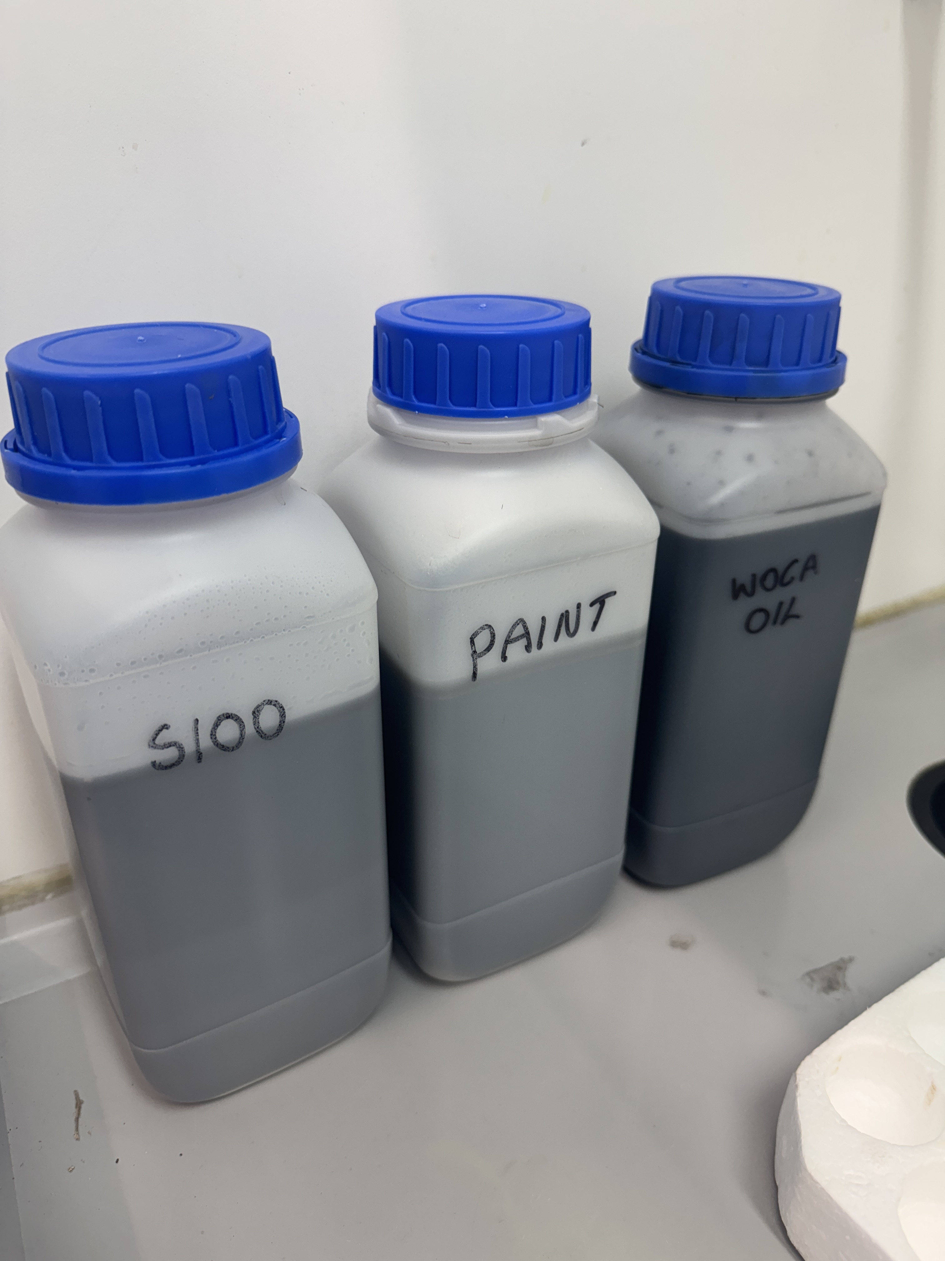 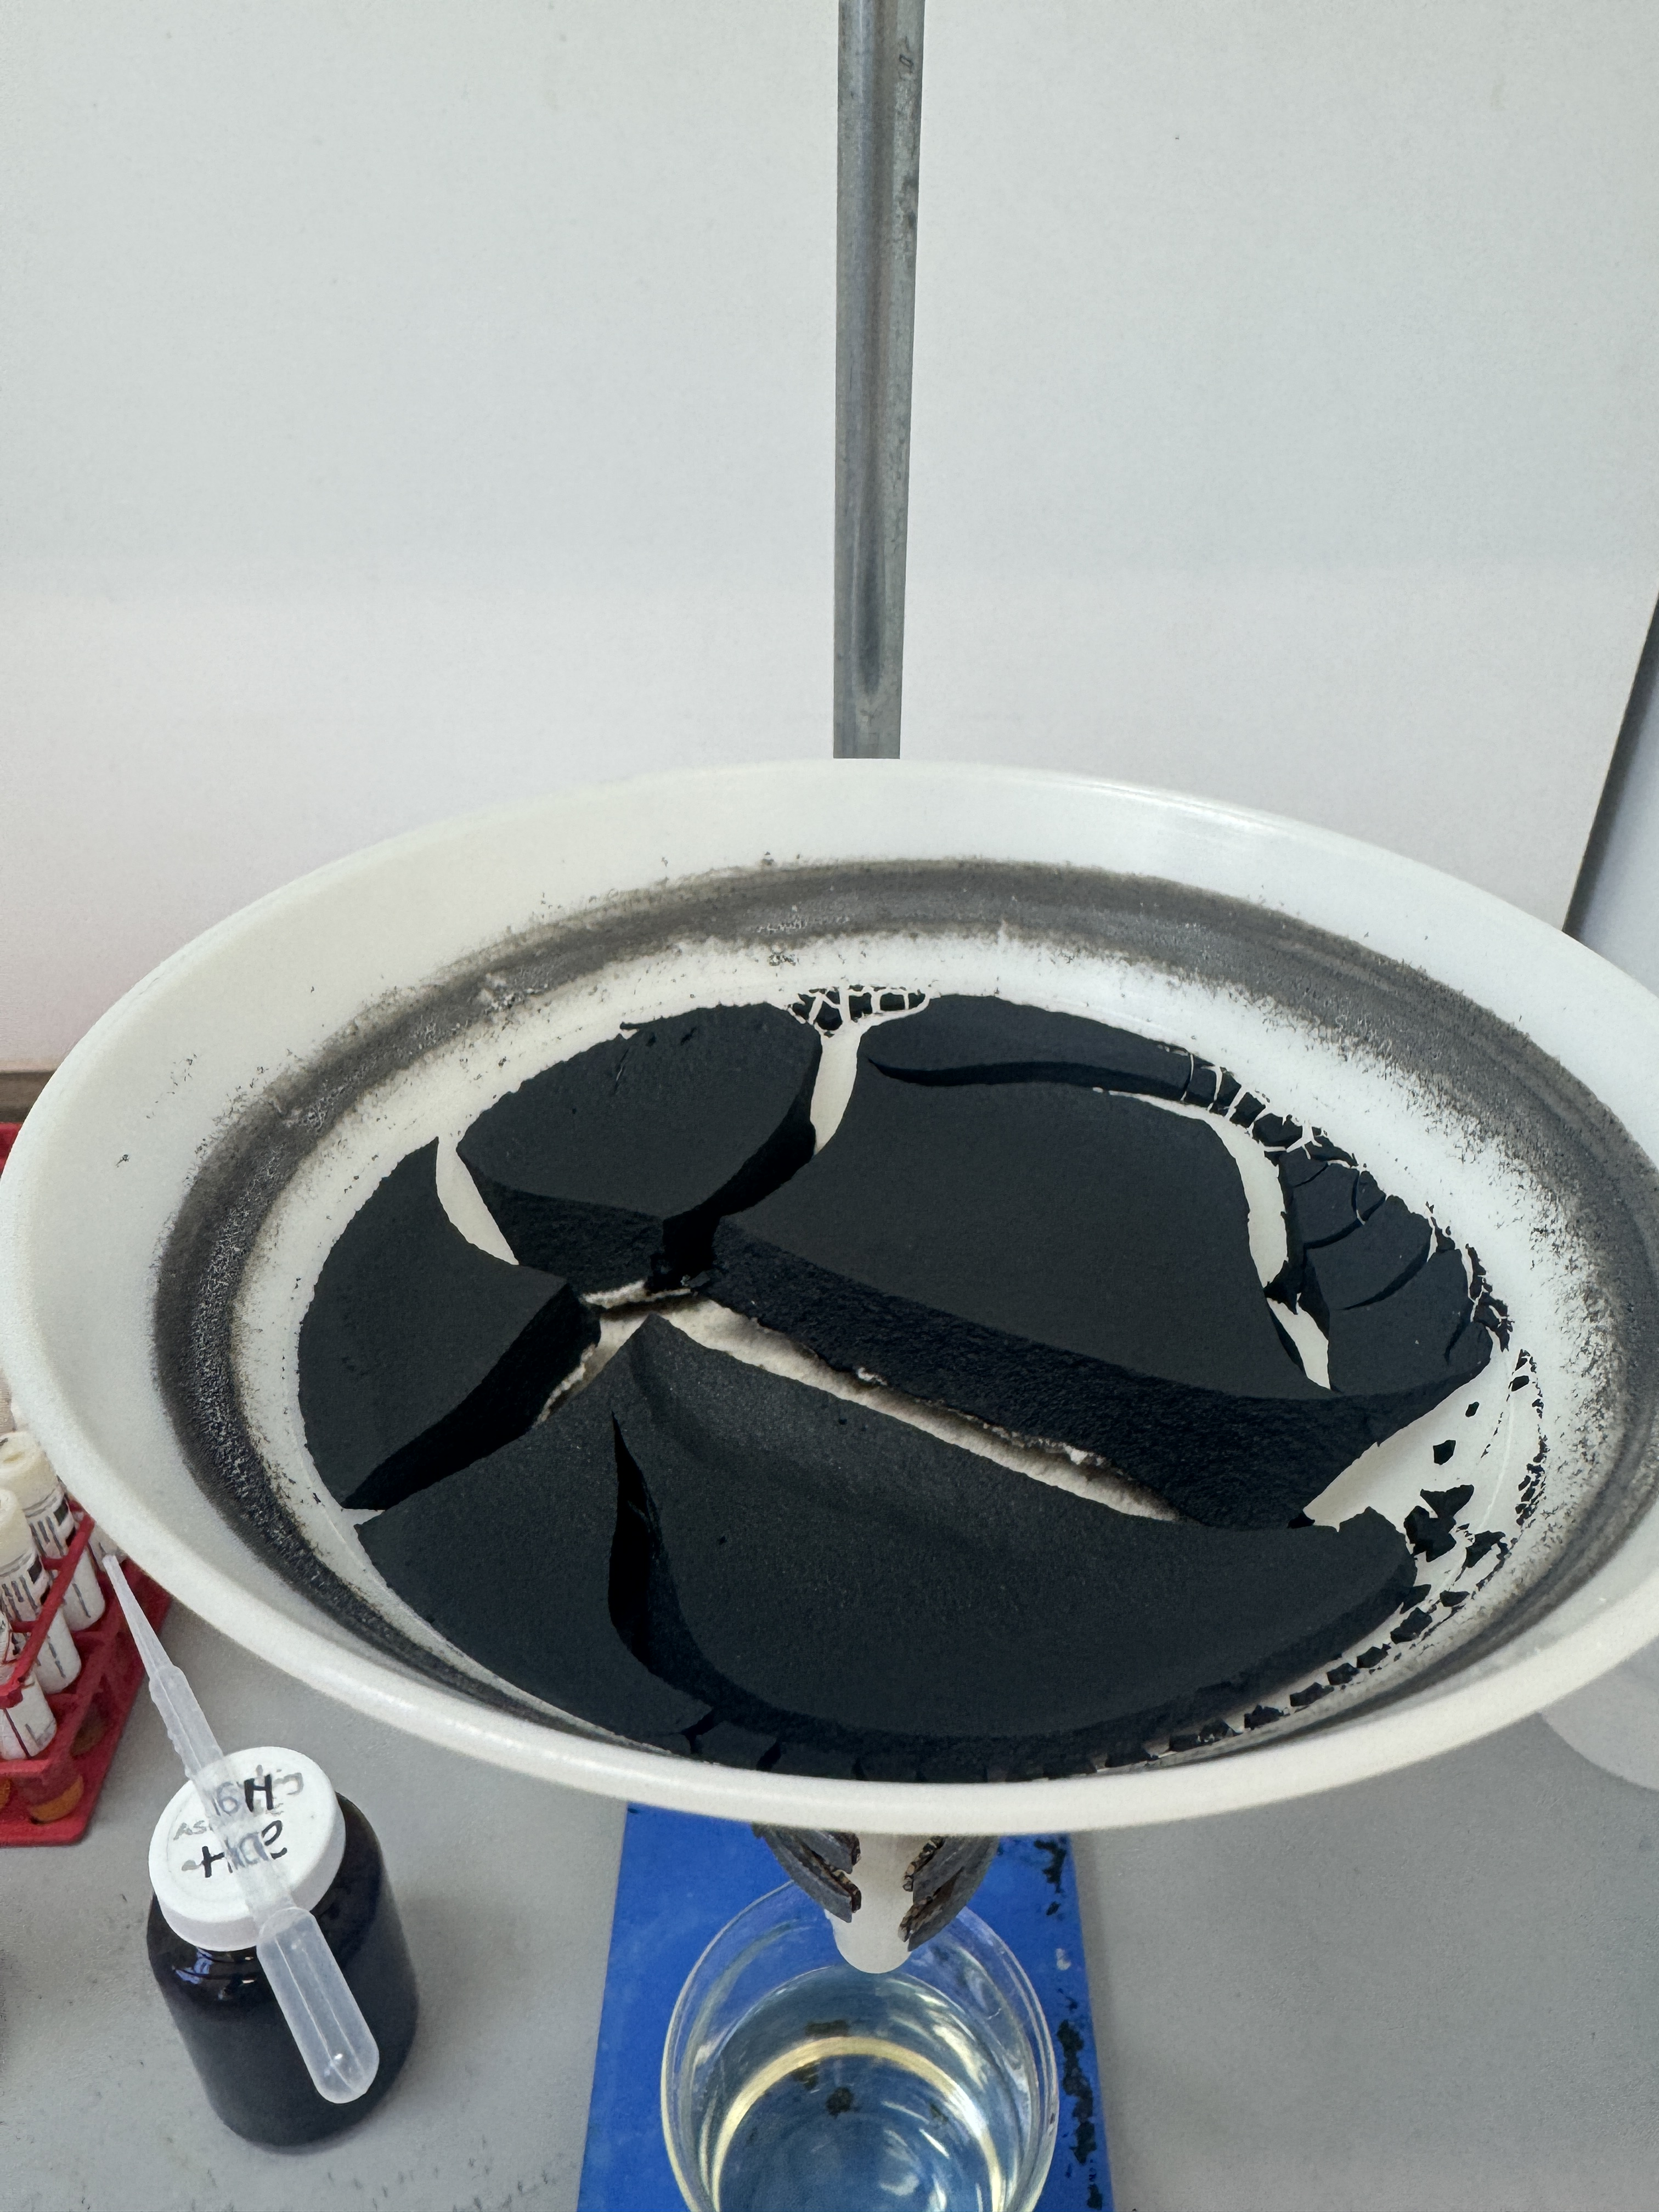 

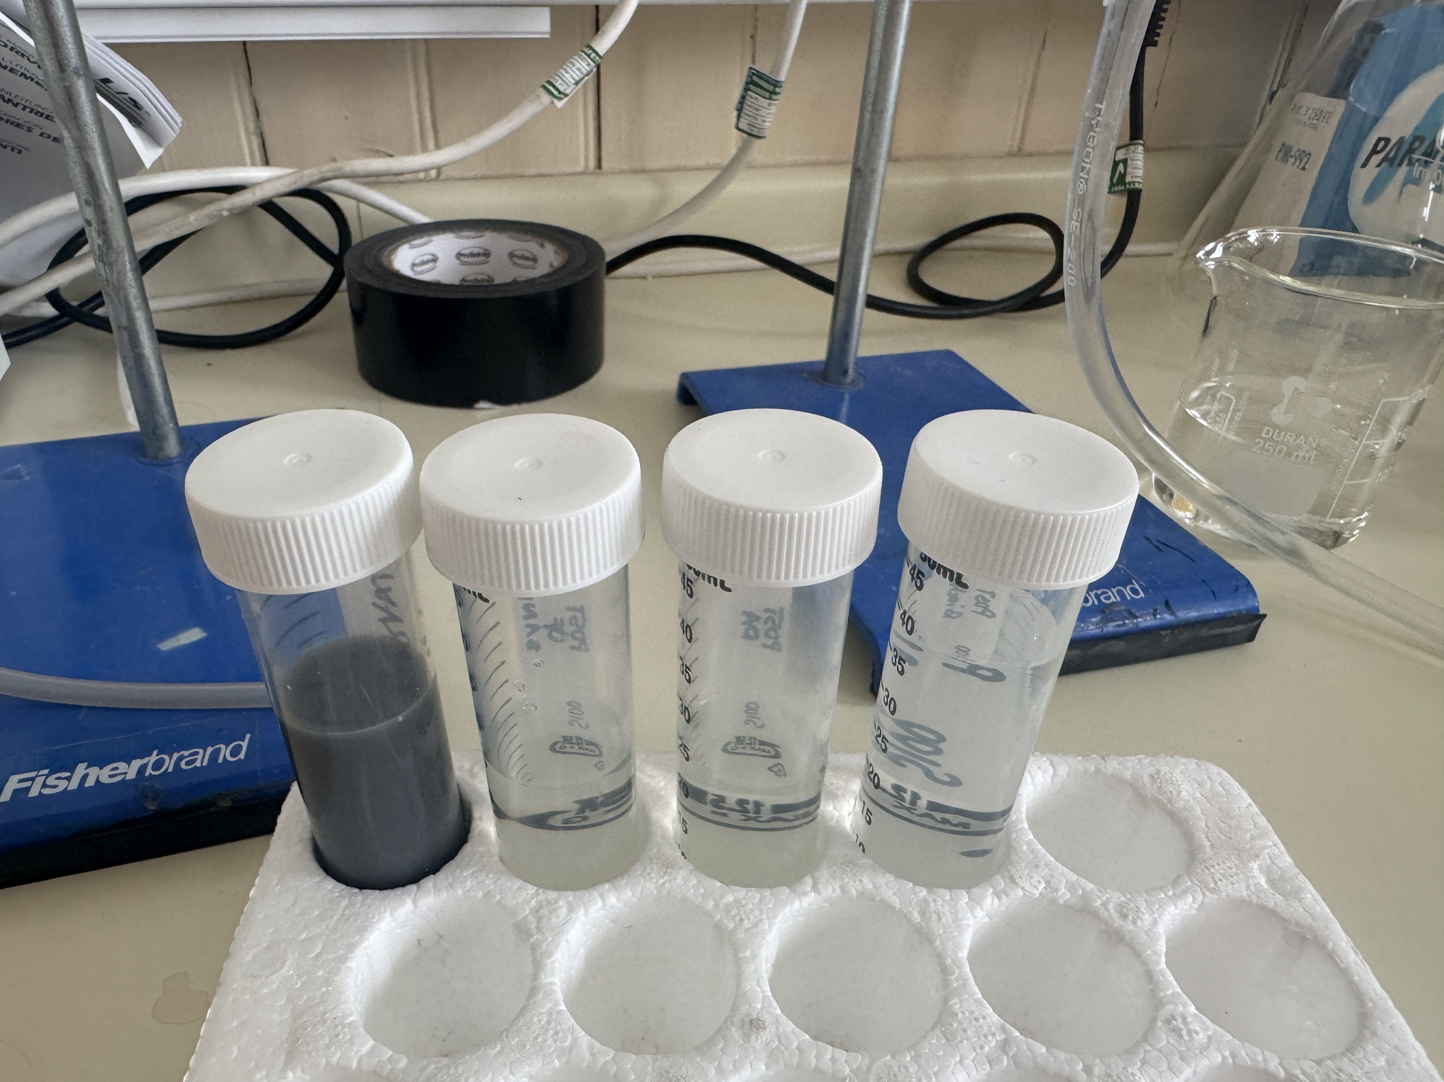

# Case Study:

**Innovative coagulant/flocculant optimisation to treat challenging wastewater from different industry sectors**

Many industries generate highly polluted wastewater, characterised by very high (up to 120,000 mg/L) chemical oxygen demand (COD) and colloidal particles. Such effluents are not easy to treat using available standard technologies. Depending on the characteristics of the effluent to be treated, technology including sand filtration, liquid–liquid extraction, coagulation/flocculation, ion exchange, adsorption and membranes, as well as different combinations of these, could be used. While some of these established technologies require high maintenance and operational costs (i.e., membranes), treatment via coagulation/flocculation (C–F) tends to provide simple operating conditions and lower costs and these are therefore is a popular options. C-F is common in WWTPs, however, this alone tends to be insufficient when used with very high COD+dissolved solids effluents. Novel and innovative C-F’s with increased efficiency are needed to overcome this particular challenge. This project tested and optimised different C-F’s provided by AL2-Tek (an industrial partner on this project), and applied these C-F’s to highly polluted effluents including anaerobic digestate liquids (high in suspended solids, organic load and nutrients) and wastewater from the timber processing/coating industry (high in suspended solids/colloids, organic load, and paint/preservative), at lab-scale, using a well-established JAR test procedure.

Background

Project method and task:

Project Overview

The primary goal of a C–F process is to reduce effluent COD, colloidal impurities and turbidity present in wastewater. Adding a coagulant to such water alters the physical state of the suspended or dissolved solids present, encouraging coagulation. Flocculants (usually polymers) are then added after coagulation to ensure the formation of larger and denser agglomerations of particles to facilitate solid-liquid separation. The selection of C-F’s is important in order to maximise treatment efficiency, and therefore, the aim of this ‘seed-corn’ project was to test/optimise the performance of different C-F’s when applied to challenging wastewater.

The main objectives were to:

* Test the C-F’s using model solutions containing kaolin to establish baseline dosages;
* Optimise their performance with real wastewater effluent (i.e., an anaerobic digestate liquid with a COD >3,000 mg/L and a timber procesing industry wastewater with a COD >80,000 mg/L);
* Utilise sand filtration to remove all generated floculant from the water phase;
* Characterise the post treatment effluent and thus process efficiency;
* Undertake data analysis and interpretation. Project action and activities:

Project Overview

Multiple water treatment experiments were undertaken at ERI-NWH (using laboratory jar tests combined with sand filtration, plus optimisation tests and effluent characterisation) with novel C-F’s to optimise COD removal efficiency. Overall, this project demonstrated a fully integrated approach to assess the feasibility of these innovative materials for potential implementation in the water sector.

Much of ERI’s work in the Water Treatment Innovation space focusses on novel low-cost sustainable solutions for water quality management/treatment. Hence, the aims of the Industrial Partner involved here (AL2-Tek) and ERI were very much aligned. From the outset, we recognised significant scope to collaborate long-term with AL2-Tek and a very positive relationship has emerged. The collaboration has provided income (~£4.5K) and in turn this has helped support research and technical staff within ERI. The collaboration with our industrial partner has been highly effective, and communication has been excellent throughout the project. Our main contact from AL2-Tek will visit ERI in the coming month to explore further collaborations related to this research.

This collaborative project with industry is actively helping ERI make its mark within the wider water treatment research field – and this is now one of multiple projects that we have delivered in this realm, involving partners such as Whyte & Mackay, Scottish Water, Scottish Water Horizons, PyroGenesys Ltd and SEM Ltd.

Project outcomes and results:

Project Overview

* Two coagulants, namely PIX (an iron based chemical) and PAX (an aluminium based chemical) were tested during the trials.
* Two flocculants made from innovative polymeric materials were tested, namely flocculant A30 and flocculant C55 (no more details were provided by the industrial partner due to their IP policy).
* The C-F experiments were performed in the lab using a JAR test unit with six glass beakers of ~1 L capacity. The experimental process involved rapid stirring at 150 rpm for five minutes after adding the coagulant dose, followed by slow mixing at 30 rpm for a varied time with the flocculants. After particle agglomeration, sand filtration was used to separate the suspended floculant from the water phase. After each experiment a small amount of supernatant was collected for tests for COD, turbidity, pH and conductivity.
* To maximise COD removal, a set of short screening design experiments (Plackett–Burman design (PBD)) were used to vary the combination and dose of C-F’s used during the experiments.
* The combination of PIX coagulant with A30 flocculant performed best, and resulted in the most significant reduction in COD.
* For anaerobic digestate liquid, process efficiency reached >90%, with COD reduced from ~3000 mg/L to 274 mg/L, with an optimal dose of: PIX = 3 mL/L and A30 = 8 mL/L.
* The wastewater from the timber treatment industry had an initial COD concentration of ~81500 mg/L. Process efficiency after optimisation reached >50%, resulting in a residual COD of 39000 mg/L, with an optimal dose of: PIX = 4 mL/L and A30 = 5 mL/L.
* The treated water also had a neutral pH (a harsh pH environment was not required for the process), and significantly reduced conductivity and turbidity.
* **These findings highlight the efficacy and sustainability of the C-F process using these novel coagulants/flocculants, offering a practical, rapid, and cost-effective solution for highly polluted wastewaters.**

The next steps are as follows:

* The wastewater from the timber processing industry needs further treatment (after C-F and sand filtration), to achive the regulatory discharge requirements set by SEPA (<2000mg/L COD). Hence, additional filtration trials (with different biochars and activated carbons) will soon be conducted.
* Further, there are still knowledge gaps regarding the large scale applicability of these new C-F’s, therefore, field testing is now needed to confirm their efficacy at larger scales with the industrial partner.